# C# Programming - Class 2

**Assignment 04 - Inheritance and Polymorphism**



**Step 1: Research**

In this activity you will review key aspects about inheritance and polymorphism.

1. Please review the following web pages:

Inheritance

<http://www.csharp-station.com/Tutorials/Lesson08.aspx>

Polymorphism/Abstraction

<http://www.csharp-station.com/Tutorials/Lesson09.aspx>

Constructors

<http://www.codeproject.com/Articles/7011/An-Intro-to-Constructors-in-C>

### **Step 2: Applying your knowledge**

In this activity, you researched inheritance and polymorphism. Let’s apply this knowledge by completing the following.

1) Create a new Windows application that allows a user enter both employee and customer data and save this data into an array of Person objects. Add a button that will write the data from these objects into a text file.

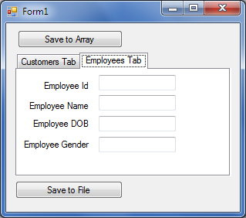 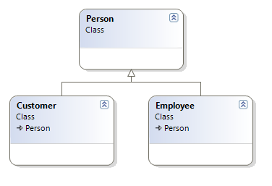

**Step 3: Submitting your work.**

Homework is graded, so you need to submit it. However, I will demonstrate the solution at the beginning of the next class and it is best if you have your version of the homework available to you while I do so. This way, you can compare your solution to mine and ask questions.